BASIC TOOL KIT
& RESOURCE GUIDE FOR YOUNG FILMMAKERS

CHILDREN’S FOUNDATION © AMERICAN FILM INSTITUTE 2008

FILMMAKER’S TOOL KIT

•GLOSSARY OF FILM TERMS

•STORYBOARD GLOSSARY OF COMMON FILM SHOTS

•GUIDE TO SCRIPT FORMATTING

•GUIDE TO 3-PONT LIGHTING

•BLANK STORYBOARDS

•PRODUCTION CALL SHEET

•PUBLISH AND CONNECT

G L O S S A R Y O F F I L M T E R M S

GLOSSARY OF FILM TERMS
Introduction

A consideration of the many disciplines involved in film production gives the motion picture a much larger and more complex dimension. No longer can a film adaptation of a novel or other literary work be considered a mere visual record when so much talent is involved in such a creative effort. Just as the various tasks in film production can be broken down and analyzed individually, so can the individual elements of the film. Filmmaking, like any other art form, has its own language and vocabulary. Once that language is mastered, films can be understood at a new level.

Camera angle: The position of the camera in relation to the subject it shows: above it, looking down (a high angle); on the same level (a straight-on angle); looking up (a low angle).

Close-up: A framing in which the scale of the object shown is relatively large. Most commonly, a personʼs head is seen from the neck up, or an object fills most of the screen to emphasize its importance.

Crane shot: A shot accomplished by having the camera above the ground and moving through the air in any direction.

Crosscutting: Editing that alternates shots of two or more lines of action occurring in different places, usually simultaneously. Crosscutting is often used during a key dramatic sequence to increase tension.

Deep Focus: A use of the camera lens and lighting so that both close and distant planes are shown in sharp focus. This technique allows the filmmaker to emphasize a character or object that appears far away.

Depth of Field: The area or field between the closest and farthest planes captured by the camera, in which everything appears in sharp focus. A depth of field from five to 16 feet, for example, would mean that everything closer than five feet and farther than 16 feet would be out of focus.

Dissolve: A transition between two shots during which the first image gradually disappears while the second image gradually appears. For a moment, the two images blend in superimposition.

G L O S S A R Y O F F I L M T E R M S

Establishing shot: A shot that shows the relationship among important figures, objects, characters and setting at a distance. From the establishing shot, the film then cuts to more detailed shots (often called coverage) that bring the audience closer to the characters.

Flashback: An alteration in the story order in which the plot moves back in time to show events that have taken place earlier than those already shown.

Focus: When light, people, places and objects are captured on film showing sharp outlines and distinct textures through manipulation of the camera lens. There are different types of focus, used to achieve specific effects.

Frame: The rectangular box that contains the image projected on the screen. This perimeter is one of the filmmakerʼs most important tools. The frame is the window into the world of a film. Within it, each shot is composed and the edges of the frame allow the filmmaker to create a picture. Movies were first known as moving pictures, and this
description is still useful when considering the important role the frame plays as a
compositional device. Through the cameraʼs eye, the viewer is presented with images that convey the story. Within the frame, the filmmaker creates several different types of shots, which are generally characterized by the relationship between the size of the elements in the frame to each other and to the frame itself.

Long shot: A framing in which the scale of the object shown is not distant but relatively small. A standing human figure, for example, generally appears nearly the height of the screen.

Medium shot: A shot that shows human figures from the waist up.

Pan (or panning shot): A camera movement with the camera body turning to the right or left. On the screen, it produces a mobile framing, which scans horizontally. Panning shots can also emphasize movement.

Point of View (POV) shot: A shot taken with the camera placed where the characterʼs eyes would be to show what the character would actually see. This type of shot is usually cut in before or after a shot of the character looking at whatever the POV shot contains.

Wide angle: The use of a wide-angle lens to create a shot that captures a wide range of elements or objects on a single plane, while at the same time exaggerating the distance between foreground and background planes.

Zoom: A lens which allows the focal length—the distance between the camera and the object being filmed—to change during a single shot. The camera can zoom in by going closer to an object, or it can zoom out by pulling back from an object.

G L O S S A R Y O F F I L M T E R M S

Behind the Camera

In order to understand film as an art form, it is important to consider the jobs of the numerous individuals who work together to make the film a reality.

Producer: The person or group responsible for managing the production from start to finish. The producer develops the project from the initial idea, makes sure the script is finalized, arranges the financing, hires the personnel to make the film and oversees its distribution to theaters. The producer also coordinates the filmmaking process to ensure
that everyone involved in the project is working on schedule and on budget. Ironically,
the producerʼs role is often invisible to the movie-going public, who tend to focus on actors and directors. Yet, without the producer at the helm, films do not get made.

Director: The individual primarily responsible for overseeing the shooting and assembly of a film. He or she is most directly responsible for the pictureʼs final appearance. The director is sometimes referred to as the author or auteur of a film because of his or her essential involvement with its creation. While the director might be compared to a novelʼs author as a filmʼs primary visionary, he or she would not be able to make the film without the help of numerous other artists and technicians. In fact, the notion of the director as author is misleading because it assumes the director does everything—just like an author writes an entire book—which is not the case. A director works at the center of film production, but is inextricably linked with dozens of other people to get the job done.

Screenwriter: While the dialogue in a film may seem natural to the viewer, a writer carefully crafts it. The screenwriter does far more than provide dialogue for the actors. He or she also shapes the sequence of events in a film to ensure that one scene leads logically to the next, with the story being told in a logical and interesting way. When using a novel or play as a starting point, the screenwriter inevitably rearranges, adds or eliminates scenes to make sure the final order or sequence of scenes makes sense when presented on the screen. The screenwriter also includes descriptions of settings and often suggests movements or gestures for the actors. Like the producer, the screenwriterʼs role is generally overlooked by the movie-going public, yet is essential to the completion of any film. If there is no script, there is no movie.

G L O S S A R Y O F F I L M T E R M S

Production Designer: Before one inch of film is shot, the production designer is the first artist to translate the script into visual form. He or she creates a series of storyboards that serve as the filmʼs first draft. A storyboard is a series of sketches, paintings or watercolors arranged on panels to show the visual progression of the story
from one scene to the next. The production designer determines the palette of colors to
be used and often provides important suggestions about the composition of individual shots. Creating this sketch of the film on storyboards also ensures the visual continuity of the film from start to finish. Storyboards serve as the directorʼs visual guide throughout the production.

Art Director: The art director is responsible for the filmʼs settings: the buildings, landscapes and interiors that provide the physical context for the characters. Art direction and production design are often and easily confused. While the production designer determines the big picture—the overall appearance, color palette and basic visual composition of the film—the art director provides the individual pieces within this framework, which includes everything but the actors themselves.

Costume Designer: Costumes convey a great deal about the filmʼs time period and the characters who wear them—their economic status, occupation and attitude toward themselves.

Cinematographer: After the production designer, art director and costume designer have finished their work on the filmʼs physical elements, the director of photography, or DP, is responsible for capturing their handiwork on film or video. The DP is an expert in photographic processes, lighting and the cameraʼs technical capabilities. When the
director wants a shot to achieve certain visual or atmospheric qualities, the DP achieves
it through his or her choice of lighting, film stock and careful manipulation of the camera. During shooting, the director and cinematographer work closely to shape each shot, using the storyboards created by the production designer as a guide. This craft is referred to as cinematography.

Editor: Shortly after shooting begins, the editor begins to organize the footage—known as the daily rushes—and arranges individual shots into one continuous sequence. Even in a single scene, dozens of different shots have to be chosen and assembled from hundreds of feet of film. The editorʼs choices about which shots to use, and the order in which to place them, have a profound effect on the appearance of the final film.

G L O S S A R Y O F F I L M T E R M S

Actors: For the audience, actors are the most visible and tangible part of the production. While they are obviously essential to any film, they are pieces in a much larger puzzle. Behind every actor is a director guiding his or her performance, a cinematographer creating the perfect light and film exposure, a screenwriter providing
plot and dialogue, an art director designing the physical environment and a costume
designer providing the proper attire. Considering an actorʼs role within this larger context also suggests that his or her job is much more difficult than just appearing on the set and reciting lines.

Music: Music has been an integral part of movies since cinemaʼs earliest days in the
1890s. A piano or organ player accompanied even the simplest silent films. The silent movie palaces of the 1920s were equipped with elaborate organs and orchestra pits to accommodate large groups of live musicians. When sound was integrated into the filmmaking process, music, sound effects and dialogue became essential tools for enhancing a filmʼs visual qualities. Writing movie music has been a full-time profession since the 1930s and is still a critical component in filmmaking.

AFI SCREEN EDUCATION STORYBOARD GLOSSARY OF COMMON FILM SHOTS

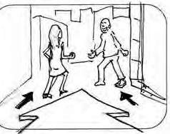
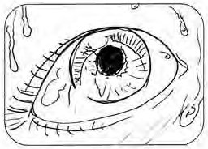
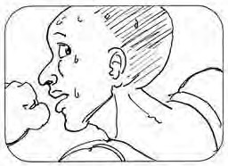

Illustrated by
Scott Hardman

© American Film Institute, 2004

G L O S S A R Y O F C O M M O N F I L M S H O T S

Introduction

Storyboards are illustrations displayed in sequence for the purpose of crafting an animated or live-action film.

In preparing to shoot a motion picture, a storyboard provides a visual layout of events as they are to be seen through the camera lens. When storyboarding, most technical details involved in crafting a film can be efficiently described in pictures, or in corollary notation.

A storyboard is essentially a large comic of the film or some section of the film, produced before filming to help directors and cinematographers visualize scenes and identify potential problems before they occur. Some directors storyboard extensively before taking the pitch to their funders. Others only storyboard complex scenes, or not at all.

In animation and special effects, the storyboarding stage is essential and may be followed by simplified video mock-ups called “animatics” to give a better idea of how the scene will look with motion.

screennation.afi.com m

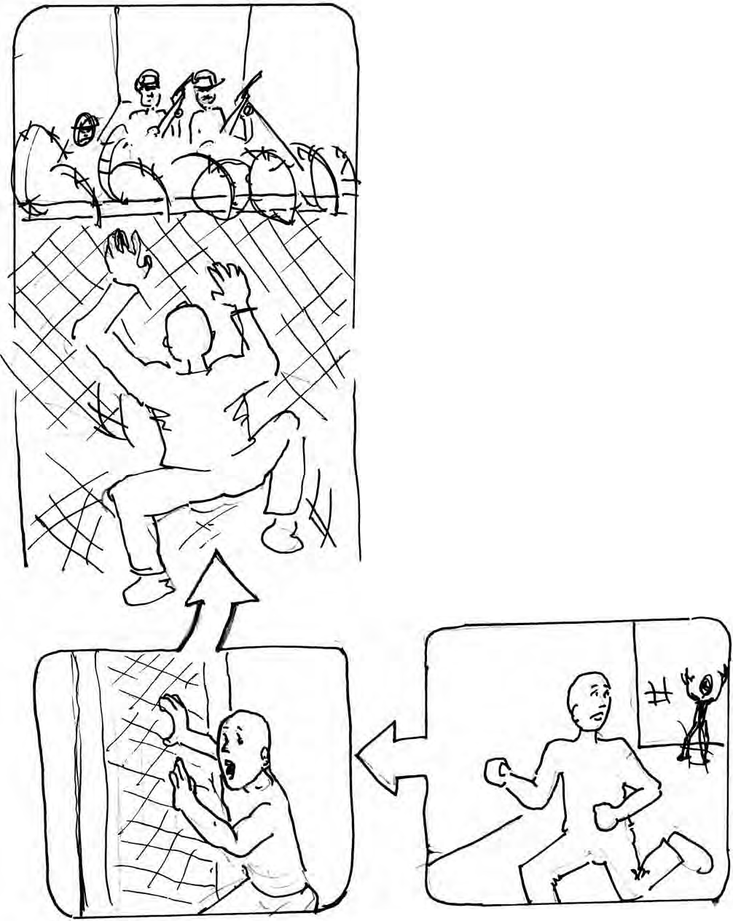

BOOM SHOT

A shot filmed from a moving boom,incorporating different camera angles and levels.

Screen
FI
,. Education

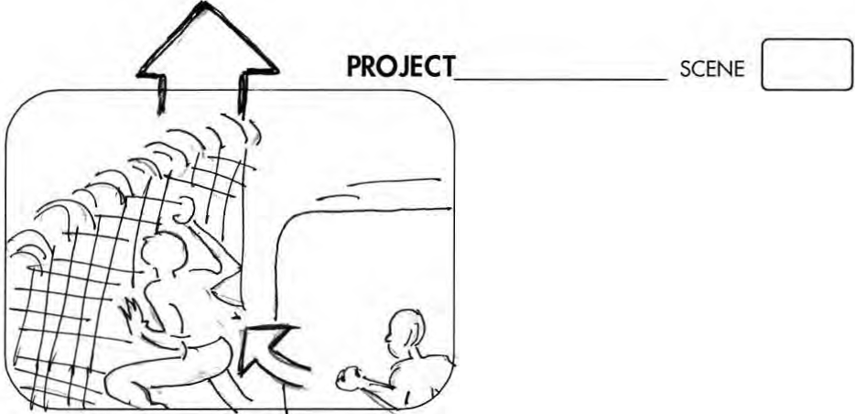
I CHOKER
A tight close-up, usually only

showing a subject's face.

I BOOM
A shot filmed from a moving boom, incorporating different camera angles and levels.
I CAMEO SHOT
A shot in which the subject
is filmed against a black or
neutral background.

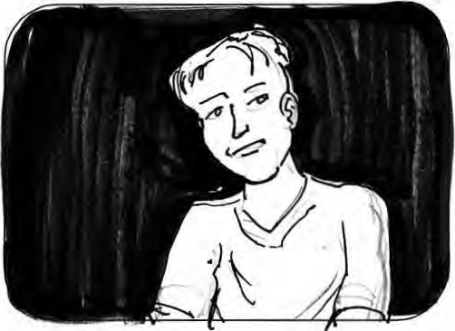

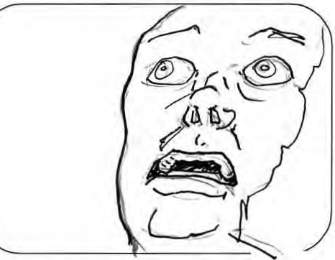

PROJECT _ SCENE c=J
I CLOSE-UP (CU)
A shot of an isolated
art of a subject or
obiect, such as the
head or hand .

I CUTAWAY
A shot that is related to the
main action of the scene
but briefly leaves it, such
as an audience member's
reaction to a show.

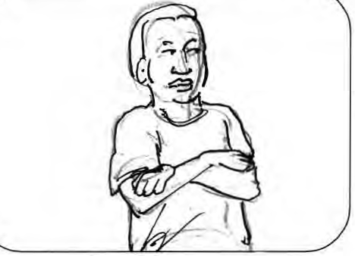
----------------
J CLOSE SHOT (CS)
A shot in which the
subject is shown from

the top of the head
to mid-waist.

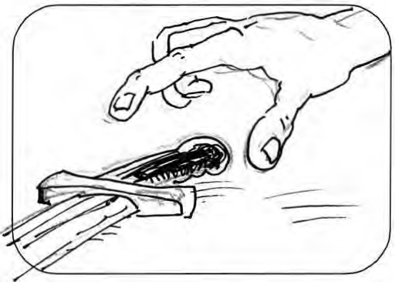

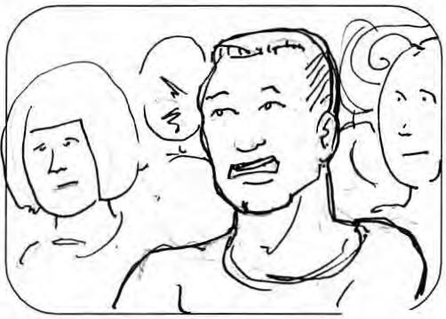

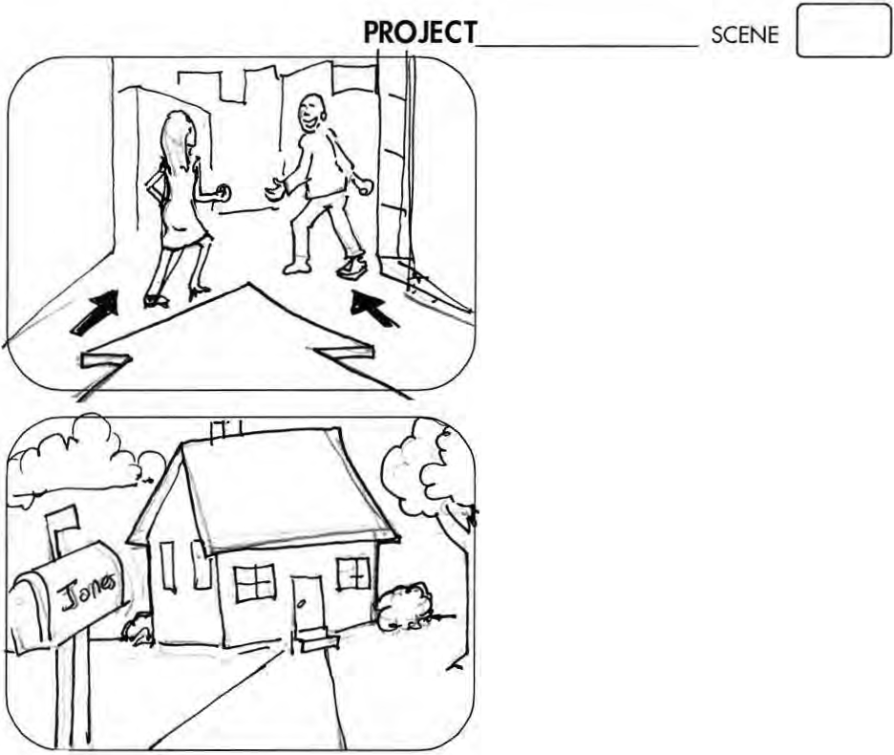
EXTREME CLOSE-UP (ECU, xcu) A magnified shot of a small detail, such as a
subiect's eyes.

I DOLLY SHOT
A moving shot,

accomQiished by moving the camera as if on a set of tracks.

I ESTABliSHING SHOT A long shot that shows location and mood.

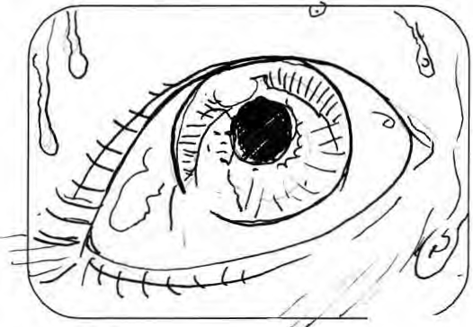

---:::-:: o------

PROJECT
SCENE CJ

-
l EYE LEVEL SHOT
A shot of the subject
at e_ye level.

EXTREME lONG SHOT (ELS,XLS)

A wide angle shot from a great distance/ such as an aerial or high
angle shot of a location.

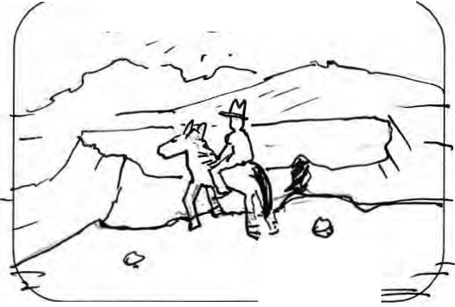
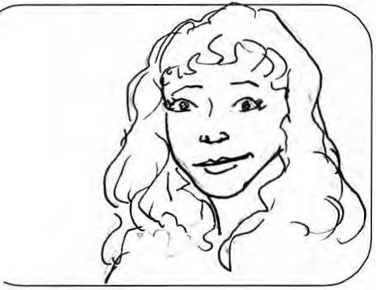
l FLASH
A very brief shot
1
often for shock effect.

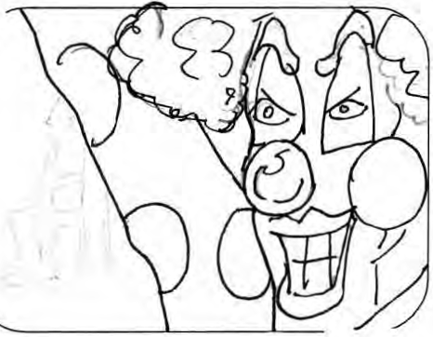

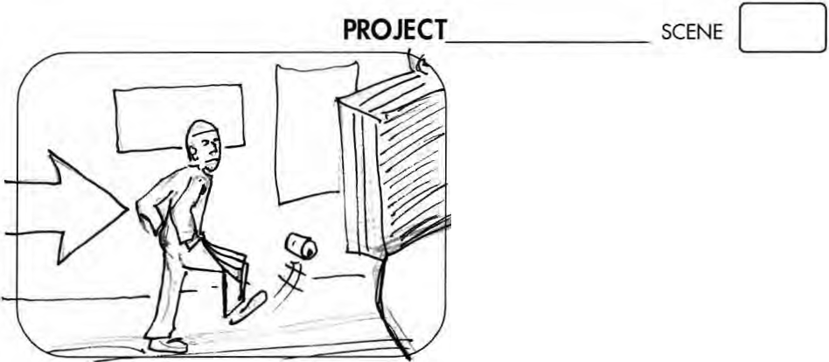
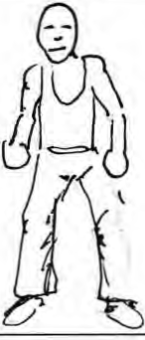
l FOLLOW SHOT A shot in which the

camera follows the subiect.
J FREEZE FRAME
A shot that results from
re_e_eating the same
frame so the subject
a QQ_ears frozen.

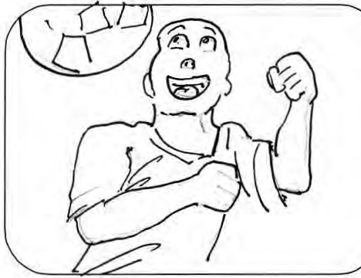

I FULL SHOT (FS)
A long shot that
captures the subiect's
entire body head to toe.

PROJECT
--- 0-----
I HEAD-ON SHOT
A shot where the action
comes directly at
the camera.

SCENE [=:J

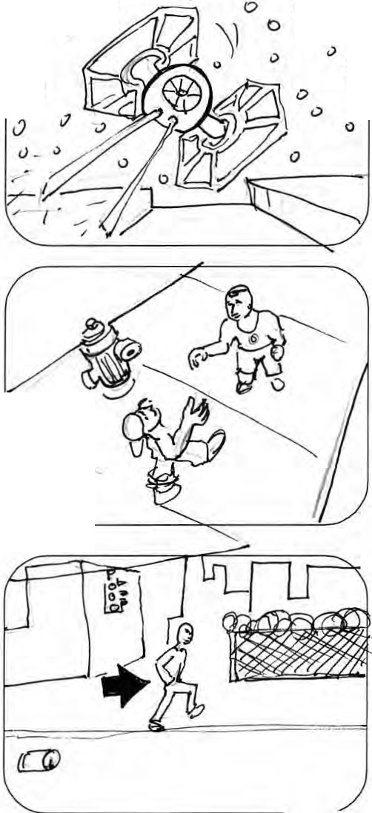
0 0 (.) 0
0 0
0
0
0

I HIGH ANGLE SHOT A shot filmed from hi_g_h
above the subject(s).

-.

I LONG SHOT (LS)
A shot in which the
subiect(s) is at a
distance, often showing
surroundin_g_s.

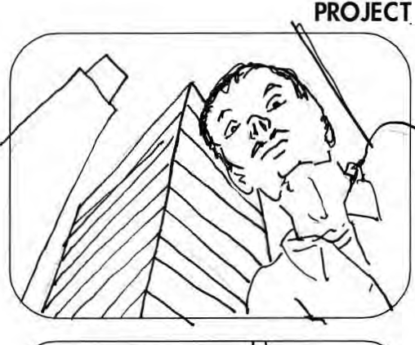
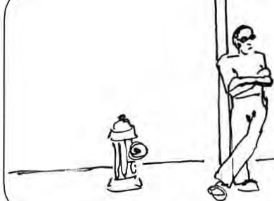
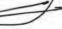
_ SCENE c=J

A s | ! LOW-ANGLE SHOT  hot filmed down low, often looking up at
the subject(s).

MEDIUM-LONG SHOT (MLS)

A shot wider than a
medium shot but longer

than a wide shot.

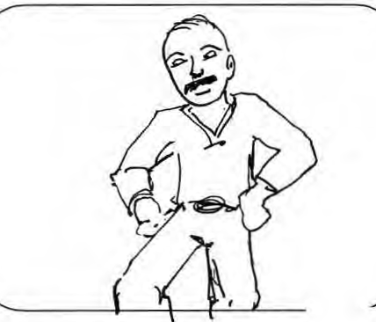

AfiScreen
I MEDIUM SHOT (MS)

A shot where the
subiect(s) is shown from

the knees up.

1\ Education

PR_O_J_ECT
SCENE c=J

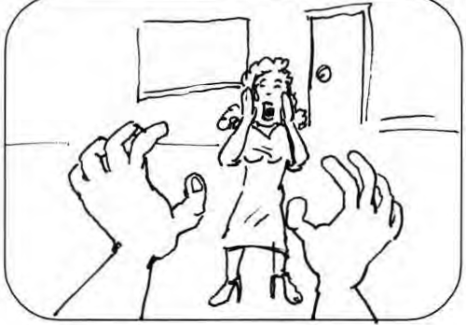
POINT-OF-VIEW SHOT (P.O.V.)

A shot from the
character's point of view.

I REACTION SHOT
A close shot of a
character reacting to
something off camera 0

REVERSE-ANGLE SHOT
A shot that is the
opposite of the
preceding shot such
as two characters
in conversation0

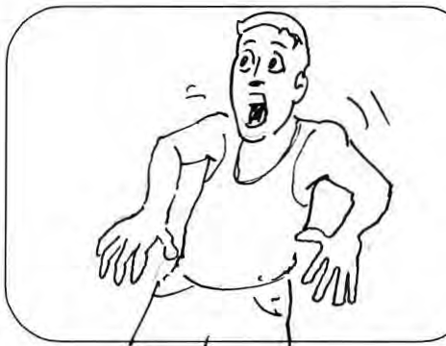

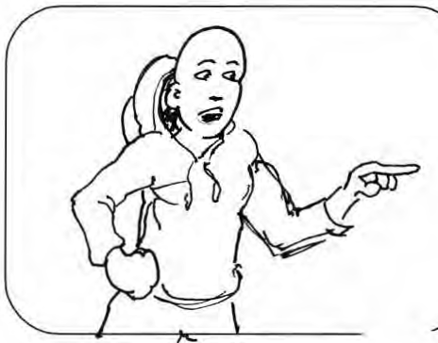

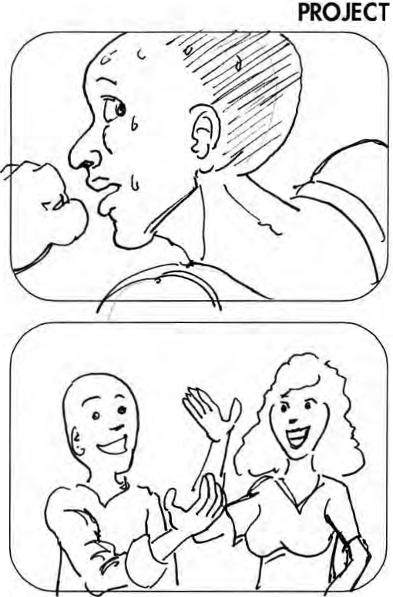
_ SCENE c=J
OVER-THE-SHOUlDER (OTS)
A shot that shows us a
character's point of view,
but includes part of that
character's shoulder or side
of t | heir head in the shot.

I TIGHT SHOT
A shot where the
subiect fills the
whole frame.

I TWO-SHOT
A medium or close shot
wide enough for two
people, often used to
film a conversation.

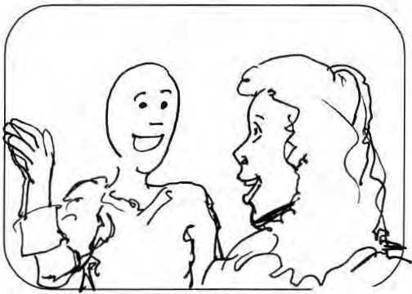

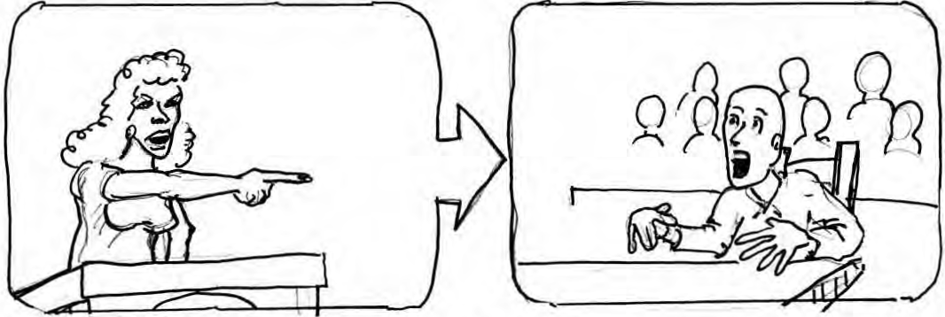

PAN SHOT A shot in which the camera moves horizontally around a fixed axis from one part of a scene
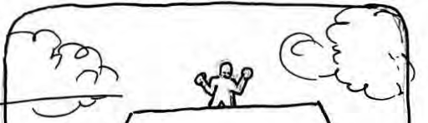
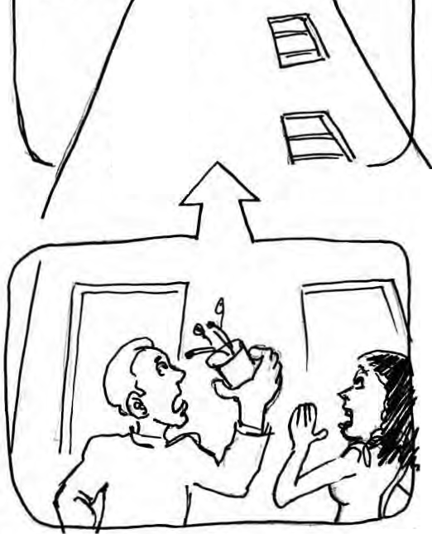
to another.

s
s TILT SHOT
A shot where the camera
moves up or down along a vertical axis,as when it looks at a building from bottom to top.

7AfiScreen
:..... Education

S C R I P T F O R M AT T I N G G U I D E

SCRIPT FORMATTING GUIDE

Cover / Title Page:
• Title & screenwriter(s) names in the middle.
• Contact information is located in the lower right corner.

Page Margins:
• Top: 1.0"
• Bottom: 1.0"
• Left: 1.5"
• Right: 1.0"

Font: Always use 12-point Courier; no bold face or italics. Use underlines instead.

Page Numbering: Place the page number on every page in the upper right corner, except the cover and the first page.

Spacing: Double space between slug line, action line, speaking character, stage directions and dialogue. Single space action lines and lines of dialogue.

The Slug Line: The general or specific locale and time of day. Always in ALL CAPS.

Action Line: Sets the scene with a description of characters, places and action single spaced from margin to margin. New characters are always capitalized. After the characters have been introduced, their names no longer need to be capitalized.

Character Speaking: 3.5" from left margin and always in ALL CAPS.

Dialogue: 2.5" from left margin.

Voice Over: Indicated by placing (VO) immediately to the right of the character name.

Off Camera: To indicate that a character is speaking off screen, place (OC) immediately to the right of the character name. This is sometimes done as (OS) for off screen.

Stage directions (or parenthetically): Written in parenthesis and under the name of the character speaking. They should be placed 3.0" from left margin and include what the character is doing within the scene.

Sound/Music Effects are always capitalized.

Camera Directions: Use sparingly or not at all. Let the director do his or her job.

screennation.afi.com

SCREENPLAY FORMAT
by
Your Name

1. "SCREENPLAY FORMAT"

FADE IN:

EXT. LOCATION #1 – DAY

This is how to begin your screenplay. Scene headings are typed in capitals and must indicate: interior or exterior, the location, and day or night.

Scene action is double-spaced under the heading in upper
and lower case text with double-spacing between paragraphs.

Scene action should only deal with what is happening on the screen and must never stray into superfluous novelistic
text related to character thoughts or back-story.

A general rule of thumb is to limit a paragraph of scene action to four or five lines. Consider each paragraph as a significant beat of action within your scene.

INT. LOCATION #2 – NIGHT

Begin a new scene with the heading triple-spaced from the preceding scene. Always follow a scene heading with a line of scene action.

CHARACTER #1
Character cues appear in capitals
indented to around the middle of
the page, but not centered.
The first letter of each cue is
always in alignment.

CHARACTER #2
A character is designated by
either his/her first or last name,
but a role designation may be used instead with personal titles abbreviated. The designated
name should remain consistent throughout the script.

(MORE)

2.

INT. LOCATION #2 – DAY

Scene transitions are technical information indicating the method of changing from one scene to another. A general rule of thumb is that every scene will CUT TO: the next if no transition is specified.

Transitions are generally only used in shooting scripts,
but if it's absolutely necessary to specify one, it appears
against the right-margin like this.
DISSOLVE TO: EXT. LOCATION #1 - NIGHT
Always keep scene headings with the scene action. Don't
leave loose headings hanging at the bottom of a page.

It's sometimes a good idea to start a new scene on a new page if there is only a line or two at the bottom of the previous one, but scenes can break over the page easily like this.

LATER

If you need to indicate the passing of time through the same scene then use LATER as a sub-heading. There is no need to continuously repeat the master scene heading.

THE CORNER OF THE ROOM

Similarly, you can break up lengthy and complex scenes by focusing on specific areas of action with a sub-heading. This is useful when scripting large party or group scenes.

EXT. LOCATION #2 - NIGHT
Sometimes it may be necessary to hear characters when we can't actually see them.

CHARACTER #1 (O.S.)
Off Screen means the character is
physically present within the scene, but can only be heard; e.g., they are speaking from an adjoining room.

3.

CHARACTER #2 (V.O.) Voiceover is used when the character is not present within the scene, but can be heard via a mechanical device such as a telephone or radio. It is also used when a character narrates parts of your story.

INTERCUT - INT. LOCATION #1/LOCATION #2 – DAY

If it's necessary to CUT back and forth between
simultaneous actions in two different locations in the same scene, then handle your scene heading like this. Use this method when you want to show a phone conversation.

CHARACTER #1 (into phone)
You can then type your dialogue as normal.

CHARACTER #2 (into phone)
Whilst indicating that both characters are on the phone.

EXT./INT. LOCATION #1 – DAY

If you have a scene where the action is continuously moving between the interior and exterior of the same location,
such as the hall and driveway of a house, do your scene heading like this.

But use INTERCUT for cutting back and forth between two separate pieces of action inside and outside.

SERIES OF SHOTS:
A) SERIES OF SHOTS: is a group of short shots which make up
a narrative sequence, useful for advancing the story in a
rapid or economical way.

4.

B) The shots are presented in logical arrangement for the action with a beginning, middle and end point to the sequence.

C) MONTAGE: is a series of two or more images that blend into and out of each other in order to create a particular effect.

D) It is used to create an emotional environment, a main title sequence or when representing archive stock footage.

E) Both SERIES OF SHOTS: and MONTAGE: are used to avoid multiple scene headings when scenes are deemed too short (often only one shot in length) to conform to the usual formatting rules.

EXT. LOCATION #2 – NIGHT

On-screen texts, such as letters, e-mails or signs, are formatted in a couple of ways. Brief text, such as a sign, can go in the body of the scene action: "THIS IS A SIGN"

"Something longer, like a letter, is formatted like dialogue enclosed within double-quote marks. It can be in normal upper and lower case text, OR ALL IN CAPITALS depending on the text it is representing."

INT. LOCATION #2 – NIGHT
FADE TO:

It is standard practice to sign-off a film script with THE END centered on the page, preceded by FADE OUT.

FADE OUT: only ever appears at the end of a feature-length screenplay, or an act in a television script. If you want to indicate a FADE OUT: and a FADE IN: within the body of the script, then the correct transitional term is FADE TO: as above.

THE END
FADE OUT.

S T U D E N T E X E R C I S E / A S S I G N M E N T

HANDOUT:
The Illustrated Stages of Three-Point and Set Lighting

Three-Point Lighting refers to the classic use of at least three lighting elements to light a subject in a scene.

Each lighting element fulfills a different purpose – acting as the Key Light, the Fill Light or the
Back Light.

The Key Light is a lighting element that acts as the main light illuminating the subject. It can also be thought of as the brightest light on the subject.

The Fill Light is a second lighting element that illuminates the subject and “fills in” the shadows on the subject created by the key light. The amount of fill light used on the subject can create a more dramatic or a softer, more romantic effect on the subject.

The Back Light is a third lighting element that is aimed at the subject from behind them (thus the name). It casts a light on the subjects hair and shoulder in order to keep the subject from blending into the background.

Below are diagrams of a typical Three-Point Lighting Set-Up for a subject:

Overhead View Side View

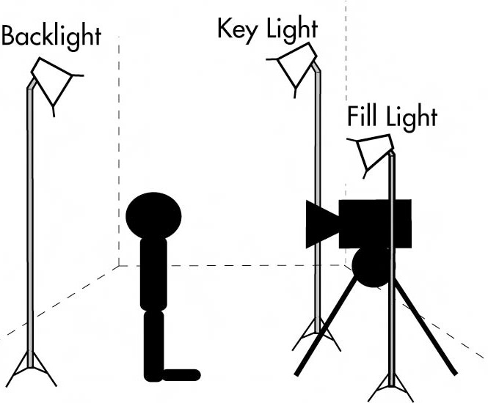
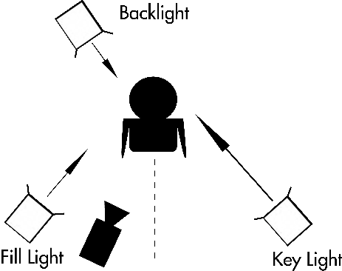

TIP: The Back Light
The back light does not need to come from above the subject, but can also come from the side or below.

S T U D E N T E X E R C I S E / A S S I G N M E N T

Here is what our subject looks like with only the lights in the room.

• Notice how the face just blends into the background.

• Also notice how it is difficult to determine what time of day the shot is supposed to represent.

• Also see how the lighting gives no indication of the mood of the scene (other than bland.)

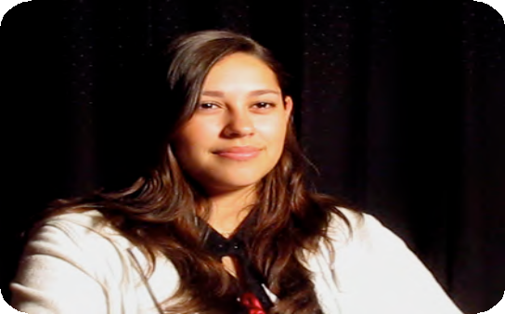
UNLIT: AREA LIGHTS ONLY

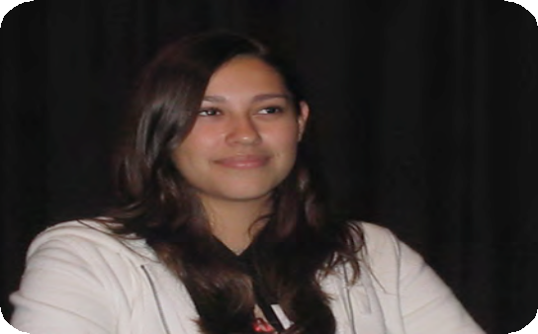
The KEY LIGHT is the main light on the subject.

• Because the key light is so bright in our picture, we are able to change the exposure, making make the background go black, thus changing the mood and
time of day.

• The key light placement is not a predetermined position. It’s position can change to fit mood, time of day and story.

• Usually the subject will be best lit if the subject is looking off somewhere between the camera and key light. Though this is not
a fixed rule

KEY LIGHT ONLY

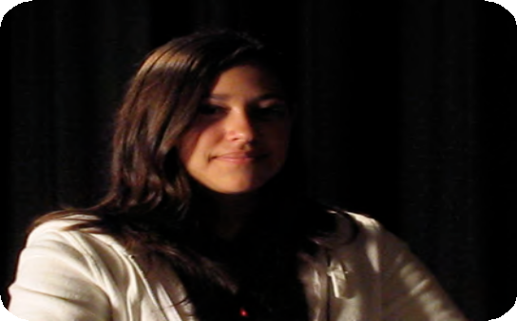
S T U D E N T E X E R C I S E / A S S I G N M E N T

The FILL LIGHT is the light that brings out details that would otherwise be lost in the shadows that are created by the Key Light. It is less bright than the Key and
often has a “softer” look.

• The more fill light is used the “softer” the subject will appear to be. The less, the more dramatic.

FILL LIGHT ONLY

Here is an example of the subject lit by both a Key and Fill Light.

• Notice how the Key Light is stronger than the Fill.

• Notice how we are now able to see the left side of the face due to the addition of the Fill Light.

FILL & KEY LIGHTS ONLY

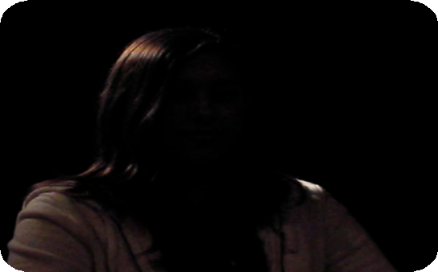
S T U D E N T E X E R C I S E / A S S I G N M E N T

BACK LIGHT is cast on the
subject from behind and creates an edge of light that separates the subject from the background.

• Back Light is usually aimed at the hair and shoulder of the subject
in order to light up the edges of the subject only.

• Be careful that the Back Light does not hit the background.

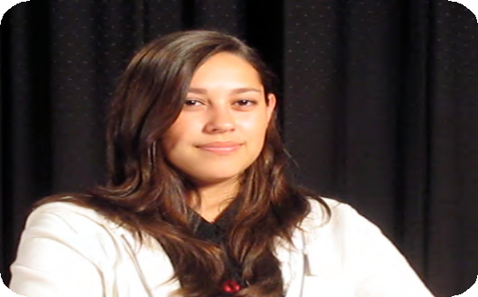
BACK LIGHT ONLY

And here is the final product of the Three-Point Lighting on the Subject using the Key, Fill and Back Light.

• Note that in this example there is no set light and therefore the location and time of day cannot be determined.

COMPLETE
THREE-POINT LIGHTING SET-UP: KEY, FILL & BACK LIGHT

S T U D E N T E X E R C I S E / A S S I G N M E N T

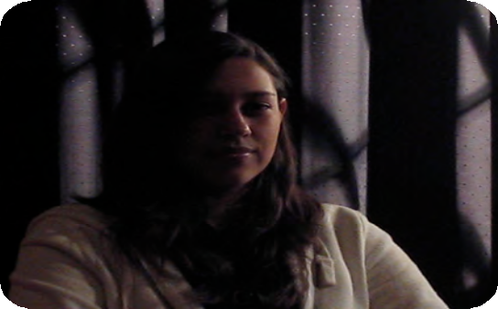
Now let’s look at Set Lights: In your future videos/films you will not only have a subject, but a set. So after the subject is lit with three-point lighting, additional lighting elements will be needed to illuminate the set, key props and to further separate the subject from blending into the background. These lights are called Set Lights.

Here is an example of a set that is illuminated with one Set
Light. The light is placed behind a “frame” in order to look like light coming into a room
through the window.

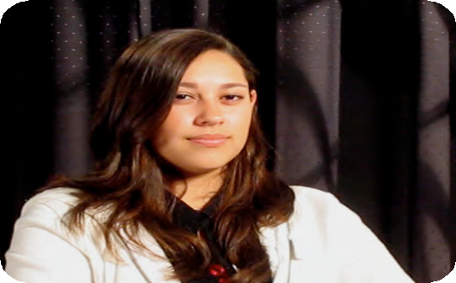
• Notice how the light coming through the window is on the same side as the Key Light. This will make it appear that the Key Light is actually coming from the light outside the window.

Here is the final product of Three-Point Lighting on the Subject with a Set Light.

• Note how the subject stands out from his background.

• Note how the Set Lights bring attention to a part of the background that clearly is important to the mood and story.

• Also note how set lighting changes a scene and successfully gives a strong feeling of place (a dark interior room), time (night) and mood (dramatic).

SET LIGHT ONLY

THREE-POINT LIGHTING WITH SET LIGHT

PROJECT
SCENE D

I

I

Afi Screen
7_:__ Education

C A L L S H E E T

Production/Group: Date:

Director: Contact #:

Producer: Contact #:

Dir. of Photography: Contact #: LOCATION (address, phone, directions):

SCENE DESCRIPTION | CHARACTER(S) | CAST | LOCATION

CAST and/or CREW MEMBER | JOB/ROLE | CONTACT #

C A L L S H E E T

CAMERA, TAPE STOCK & LIGHTING:

PROPS:

ART DEPARTMENT/SET PREPARATION:

MAKE UP & HAIR:

WARDROBE:

BE SAFE, BE SMART! It is not only your right to be safe, but your responsibility to protect yourself and others from hazards. Always mount your productions safely and legally, observing all the regulations for your school and the laws governing your location.

PUBLISH & CONNECT
Exhibit your film at SCREENNATION.AFI.COM

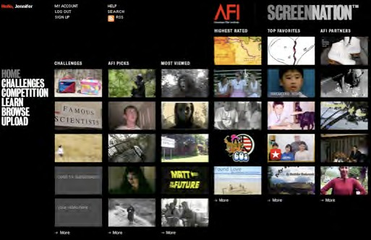
After you’ve completed your film, you are invited to join AFI ScreenNation, AFI’s FREE online community for teen filmmakers. Upload and share your videos with a global online audience and compete for prizes and recognition from the American Film Institute.

SCREENNATION.AFI.COM

•AFI ScreenNation is a portal for teen filmmakers.
•Ongoing shooting challenges
•Bite-sized production tutorials, tips and tricks.
•Full-fledged video posting and sharing to blogs, MySpace, FaceBook.
•Dynamic user interface and functionality.
•Browse and rate films submitted by other teen filmmakers.

