[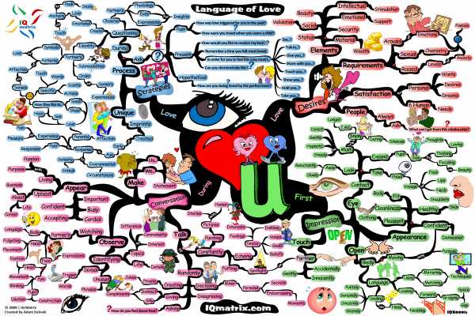](http://blog.iqmatrix.com/wp-content/gallery/life-success-series/language-of-love-mind-map-b-800px.gif)