The Journal for MultiMediaHistory
Volume 1 Number 1 ~ Fall 1998
Romeo and Juliet in Sarajevo. National Film Board of Canada, 1994. 82-minute VHS video. Produced by David Fanning, Dennis Murphy, Virginia Storring, Michael Sullivan and Mark Starowicz; Co-produced by K.A. Productions; Director, John Zaritsky; Author, John Zaritsky.
>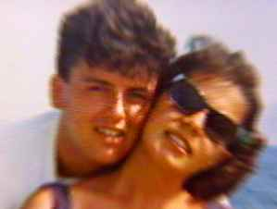
Bosko Brckic and Admira Ismic.
From Romeo and Juliet in Sarajevo.
In the spring of 1993 two young people were killed by sniper fire as they attempted to flee Sarajevo. The bodies of the Muslim woman, Admira Ismic, and her Serbian lover, Bosko Brckic, lay in each others’ arms on a Sarajevan bridge for several days, as the various factions in the brutal war assigned blame, and a picture of the dead couple dominated the international media.
Romeo and Juliet in Sarajevo traces the lives of this young couple from their high school graduation in 1986, the year Sarajevo hosted the Winter Olympics, through Bosko’s fateful decision to stay in the city of his birth when so many of his fellow Serbs left for safety, or to take part in the siege. Although the filmmakers build the documentary around the poignancy of the love story, the strength of the piece lies in the interviews and images that give a context to multiethnic disintegration and a city under attack.
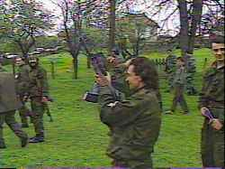
New Serbian battle recruits from Sarajevo.
From Romeo and Juliet in Sarajevo.
The interviews include Admira’s Muslim father talking about singing in a Croatian church, Bosko’s grandmother remembering the horrors of World War II, Bosko’s mother describing the shelling of their kitchen while they were watching tennis in the living room, a Serbian priest defending the necessity of defeating the Muslims for the future of Serbia, and a convicted Muslim drug dealer, now Bosnian military leader, explaining his allegiance, not just to Muslims, but to all people of Sarajevo. Inside the city, the gangster makes rock videos and negotiates escape attempts, while outside the city the priest buries the dead, but won’t pray for Admira, a Muslim, at her internment with Bosko.
The images are equally striking. Colourful family snapshots of the prewar couple at the beach soon segue into grainy video footage of mortar massacres and children dashing across streets to foil snipers who get paid 500 DM for each dead Sarajevan.
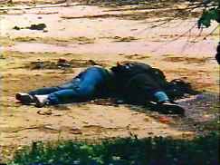
Admira Ismic and Bosko Brckic shot by snipers.
From Romeo and Juliet in Sarajevo.
We see Bosko’s two bombed out apartments, an old woman rooting up weeds for something to eat, and Admira’s nephews playing soccer in the rubble of a courtyard, afraid to leave since they saw their mother die from a single mortar shell as she put them to bed. The film ends with Croatian and Serbian soldiers describing the dying moments of the couple and the attempts to get their bodies.
Linda Kelly Alkana
California State University, Long Beach

