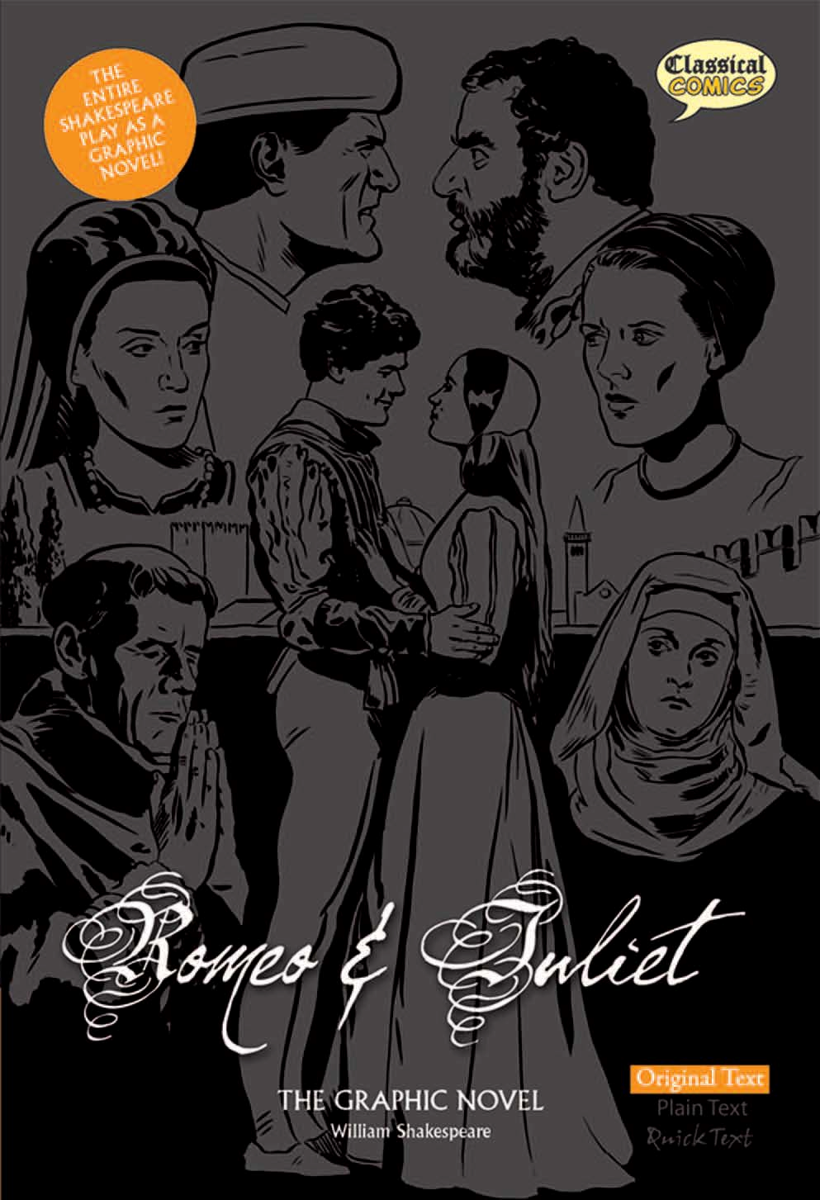

New Title Information

Classical Comics Ltd., PO Box 7280, Litchborough, Towcester NN12 9AR. Tel: 0845 812 3000
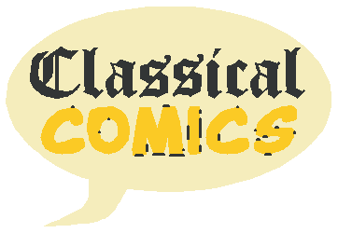

Fax: 0845 812 3005 Email: info@classicalcomics.com www.classicalcomics.com

Title: Romeo and Juliet The Graphic Novel
Sub title: Original Text Publisher: Classical Comics Ltd Author: William Shakespeare

ISBN: UK: 978-1-906332-19-8 US: 978-1-906332-61-7

Contributors: Script Adaptation: John McDonald
Linework: Will Volley
Colouring: Jim Devlin Lettering: Jim Campbell
Design & Layout: Jo Wheeler
Editor in Chief: Clive Bryant

Brief description of the book:
This is the unabridged play brought to life in full colour! Ideal for purists, students and readers who will appreciate the unaltered text. Experience the teenage love story of Romeo Montague and Juliet Capulet and their feuding families in 15th Century Italy. Coupled with stunning artwork, this is a must-have for any Shakespeare lover.

Key sales points:
• ENTIRE, UNABRIDGED ORIGINAL SCRIPT - just as The Bard intended. Ideal for purists, students and for readers who want to experience the unaltered text.
• Full colour graphic novel format.
• Meets UK curriculum requirements.
• Teaching Resource Pack available.

Publisher information:
Classical Comics is a UK publisher creating graphic novel adaptations of classical literature. True to the original vision of the author, the book has been further enhanced by using only the finest artists - giving you a truly wonderful reading experience that you’ll return to again and again.

Edition: First
Series: 1 of 3 versions available - Original Text, Plain Text & Quick Text
Pub Date: UK: September 2009 US: November 2009
Classification: Shakespeare Plays: DDS, FX
Price: £9.99 ($16.95) Format: Paperback Size: 246mm x 168mm Pages: 168 pages Age range: General
Illustrations: Full colour graphic novel illustrations throughout.

Reviews:

"Because Shakespeare is the only author we have to teach in the national curriculum, teachers appreciate any kind of help in making the plays accessible and enjoyable."

Ian McNeilly, National Association for the Teaching of English
http://news.bbc.co.uk/1/hi/education/6647927.stm
"...Shakespeare's plays were originally a combination of the visual and oral mediums.... A graphic novel bridges the visual gap for someone reading the plays. They provide the missing visual element and Classical Comics' artwork is vibrant and skillfully rendered. It leaves the page and enters the stage of the reader's mind, adding dimension and character to the text."
Lori A. Basiewicz, The Commune November 2007

55

56

57

58

59

60

61

62

